Exploratory Data Analysis Report
Diesel Price, Brent Oil, USD Exchange Rate, and Vegetable Wholesale Prices in Sri Lanka
EDA Supporting Document — Research Paper

1. Introduction
This report summarises the exploratory data analysis (EDA) conducted on weekly vegetable wholesale prices, diesel retail prices, Brent crude oil prices (in LKR), and the USD/LKR exchange rate in Sri Lanka. The analysis covers the period 2013–2019 across four major Economic Centres: Meegoda, Colombo, Kandy, and Dambulla.
The central aim of the EDA is to understand how fuel and foreign exchange costs relate to downstream vegetable prices, and why this relationship is non-trivial under Sri Lanka's administered fuel pricing regime. These findings directly inform the feature engineering and model interpretation presented in the main paper.

2. Data Overview
The dataset includes weekly records from 2013 to 2019 for the following variables:
Vegetable prices (LKR/kg): Carrot, Pumpkin, Brinjals, Beetroot, Cabbage, Leeks, Ladies Fingers, Snake Gourd, Green Beans, Green Chillies, Tomatoes, and Ash Plantains at four market locations.
Diesel price (LKR/litre): Lanka Auto Diesel retail price set by the Ceylon Petroleum Corporation (CPC). Moves in discrete policy-driven steps rather than continuously.
Brent crude price (LKR): International Brent oil benchmark converted to LKR using the prevailing USD/LKR exchange rate.
USD/LKR exchange rate: Weekly spot rate. Determines the landed cost of all imported fuel, which Sri Lanka cannot produce domestically.

3. Fuel Price Dynamics: Diesel vs Brent vs USD
Sri Lanka's diesel retail price is not market-driven in the conventional sense. The Ceylon Petroleum Corporation historically held prices fixed for extended periods — sometimes years — absorbing losses through state subsidies. A formal fuel pricing formula was introduced in May 2018 and again in 2022, making revisions more systematic. As a result, the diesel price series exhibits a distinctive step-change pattern: long flat plateaus interrupted by sudden, large adjustments.
In contrast, the Brent crude price fluctuates continuously with global supply and demand, while the USD/LKR rate drifts upward steadily with occasional sharp depreciations. These structural differences mean that simple Pearson correlation between diesel price and vegetable prices will be misleading — the relationship is regime-dependent rather than linear.

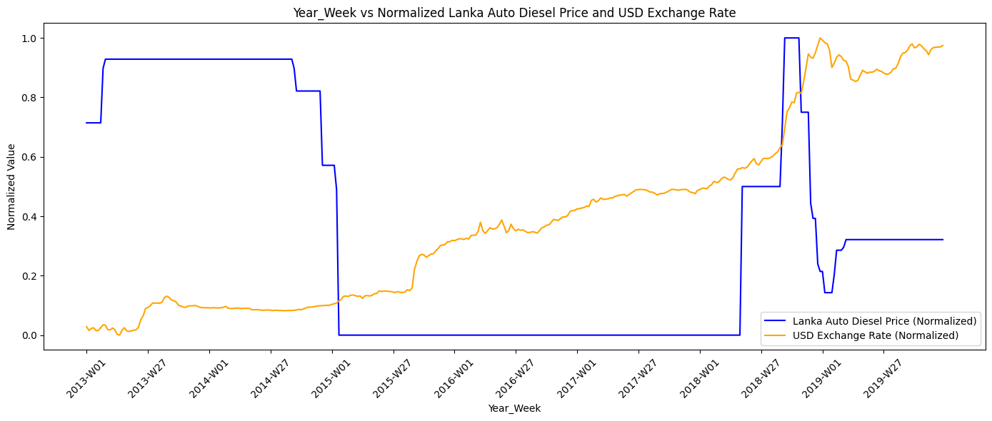
Figure 1. Normalised Lanka Auto Diesel price and USD/LKR exchange rate, 2013–2019.
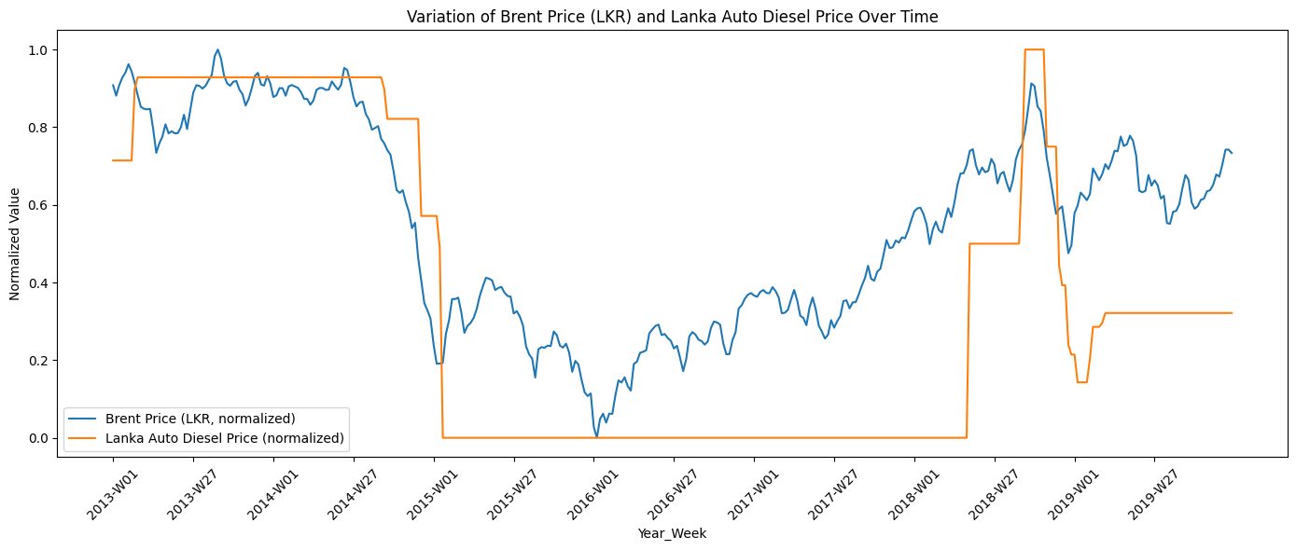
Figure 2. Normalised Brent crude (LKR) vs Lanka Auto Diesel price, 2013–2019.

4. Brent Crude vs Vegetable Prices
The Brent crude price in LKR represents the global oil market signal as received by Sri Lanka. Because Brent is a continuous variable, it allows standard correlation analysis. Across all four market locations and 12 vegetable types, Brent-LKR shows a consistently weak or even negative linear correlation with vegetable wholesale prices (r values of approximately -0.18 to -0.46).
The negative sign is counterintuitive at first glance — it does not imply that higher oil prices lower vegetable prices. Rather, it reflects a confounding period structure: global oil was high in 2013–2014 while Sri Lanka's vegetable prices were structurally lower, and the opposite held in 2015–2016 when the oil crash coincided with supply shocks that pushed vegetable prices up.

4.1 Time Series Comparison
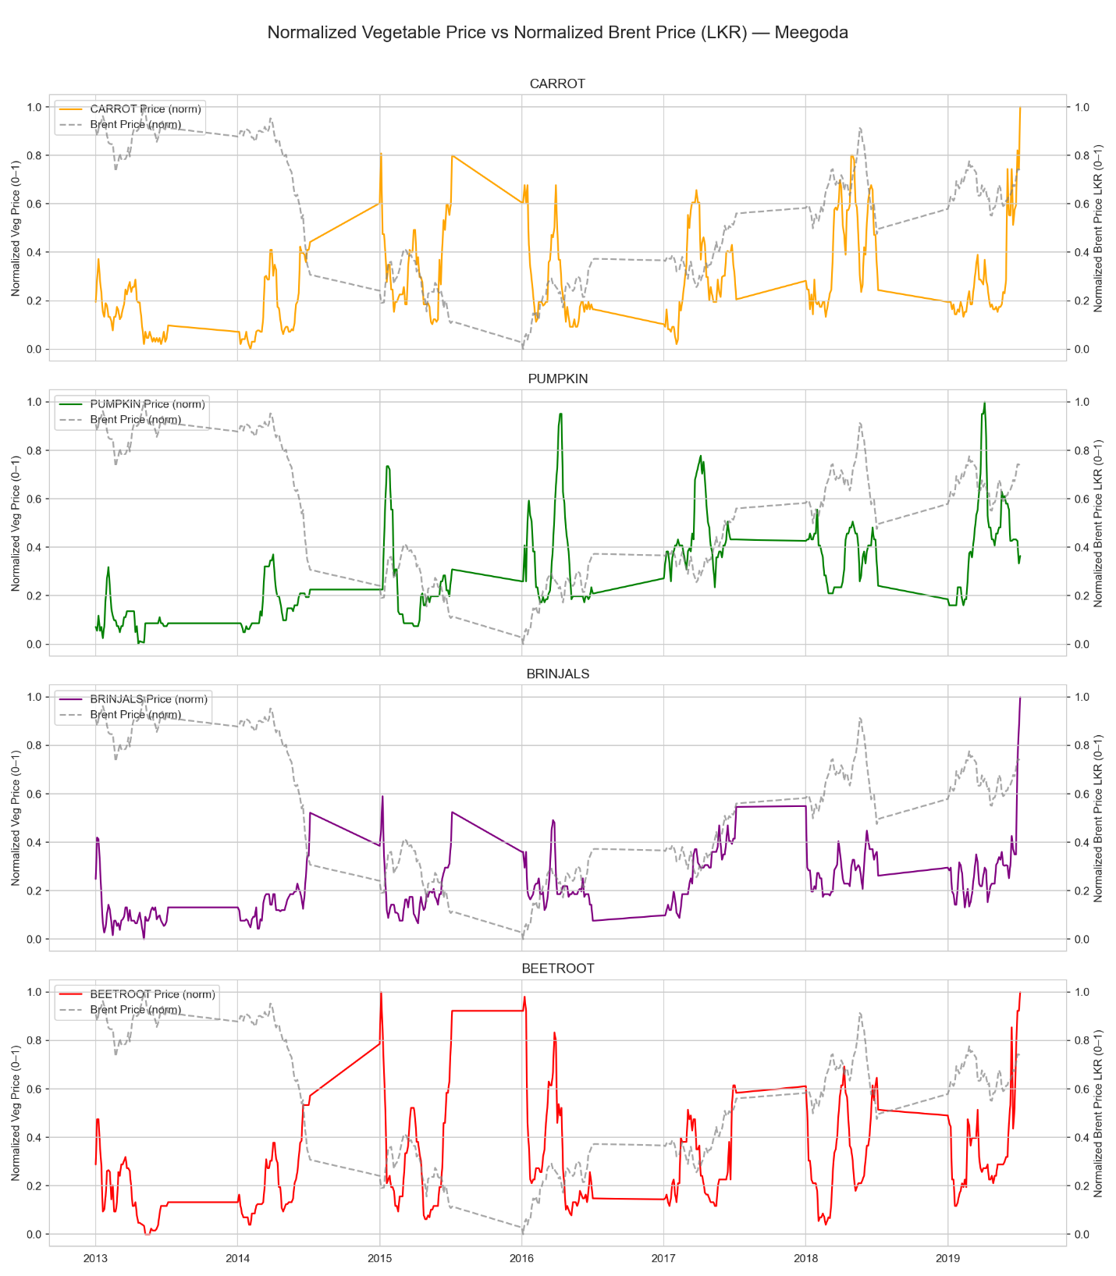
Figure 3. Vegetable prices vs Brent LKR — Meegoda, 2013–2019.
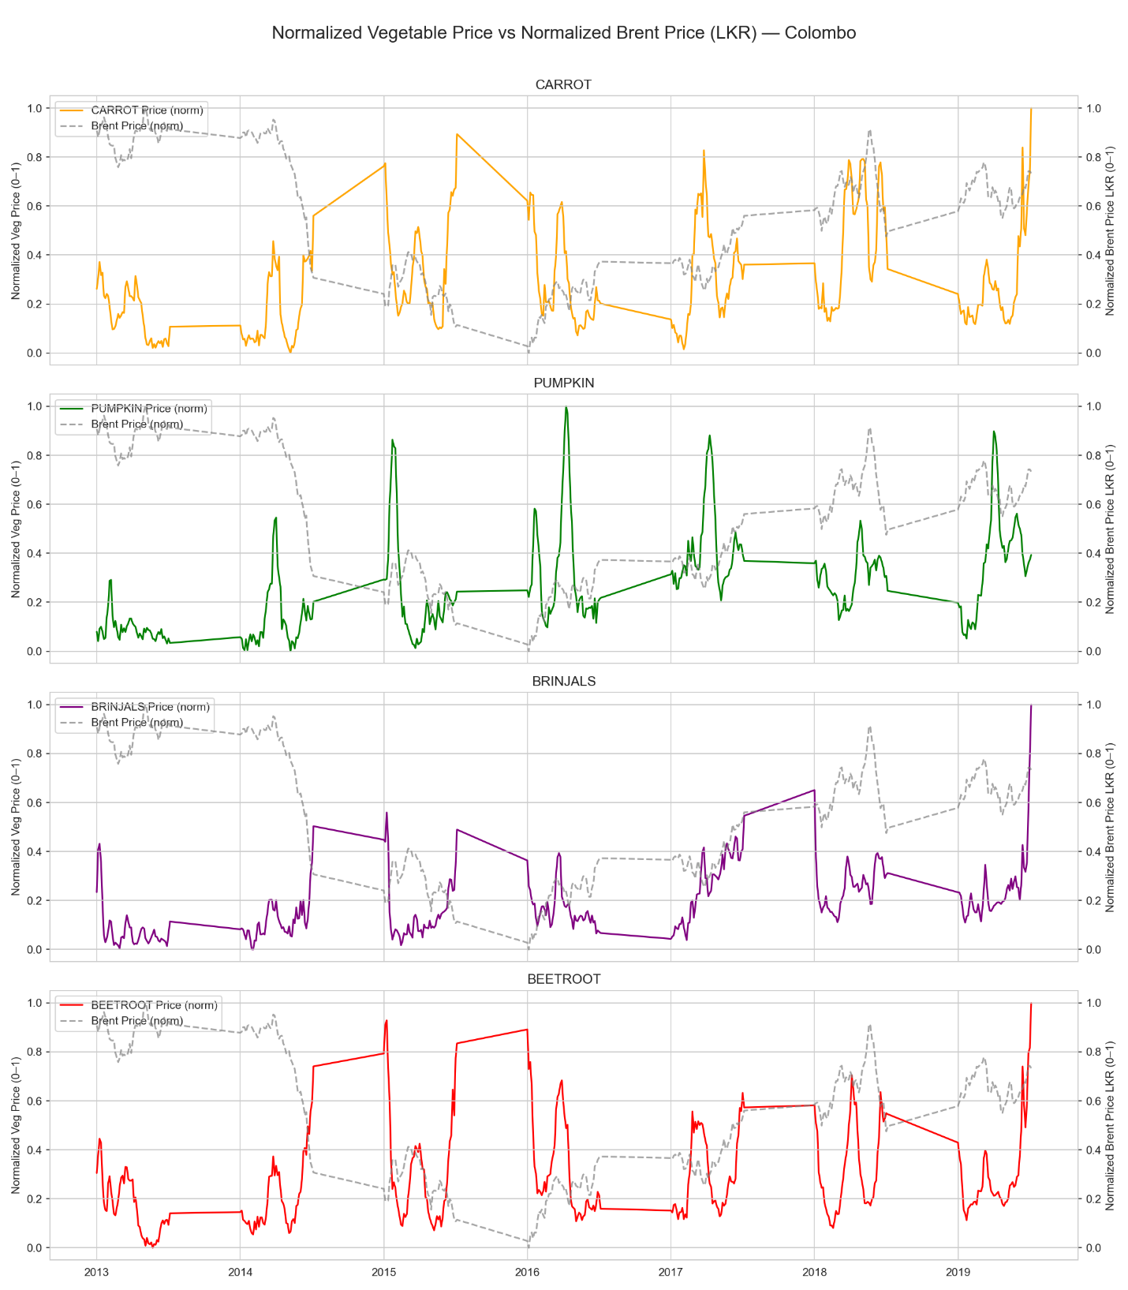

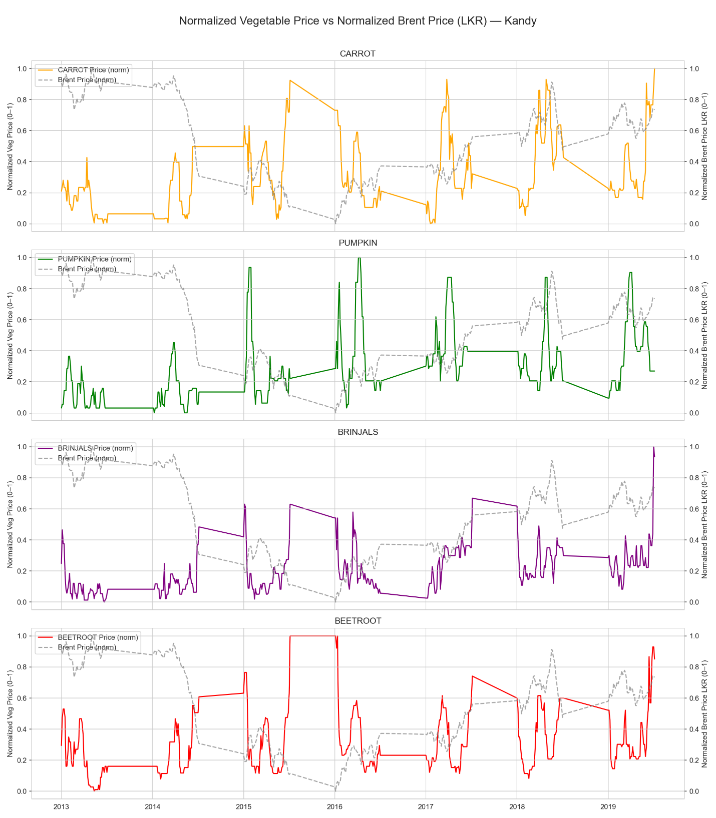

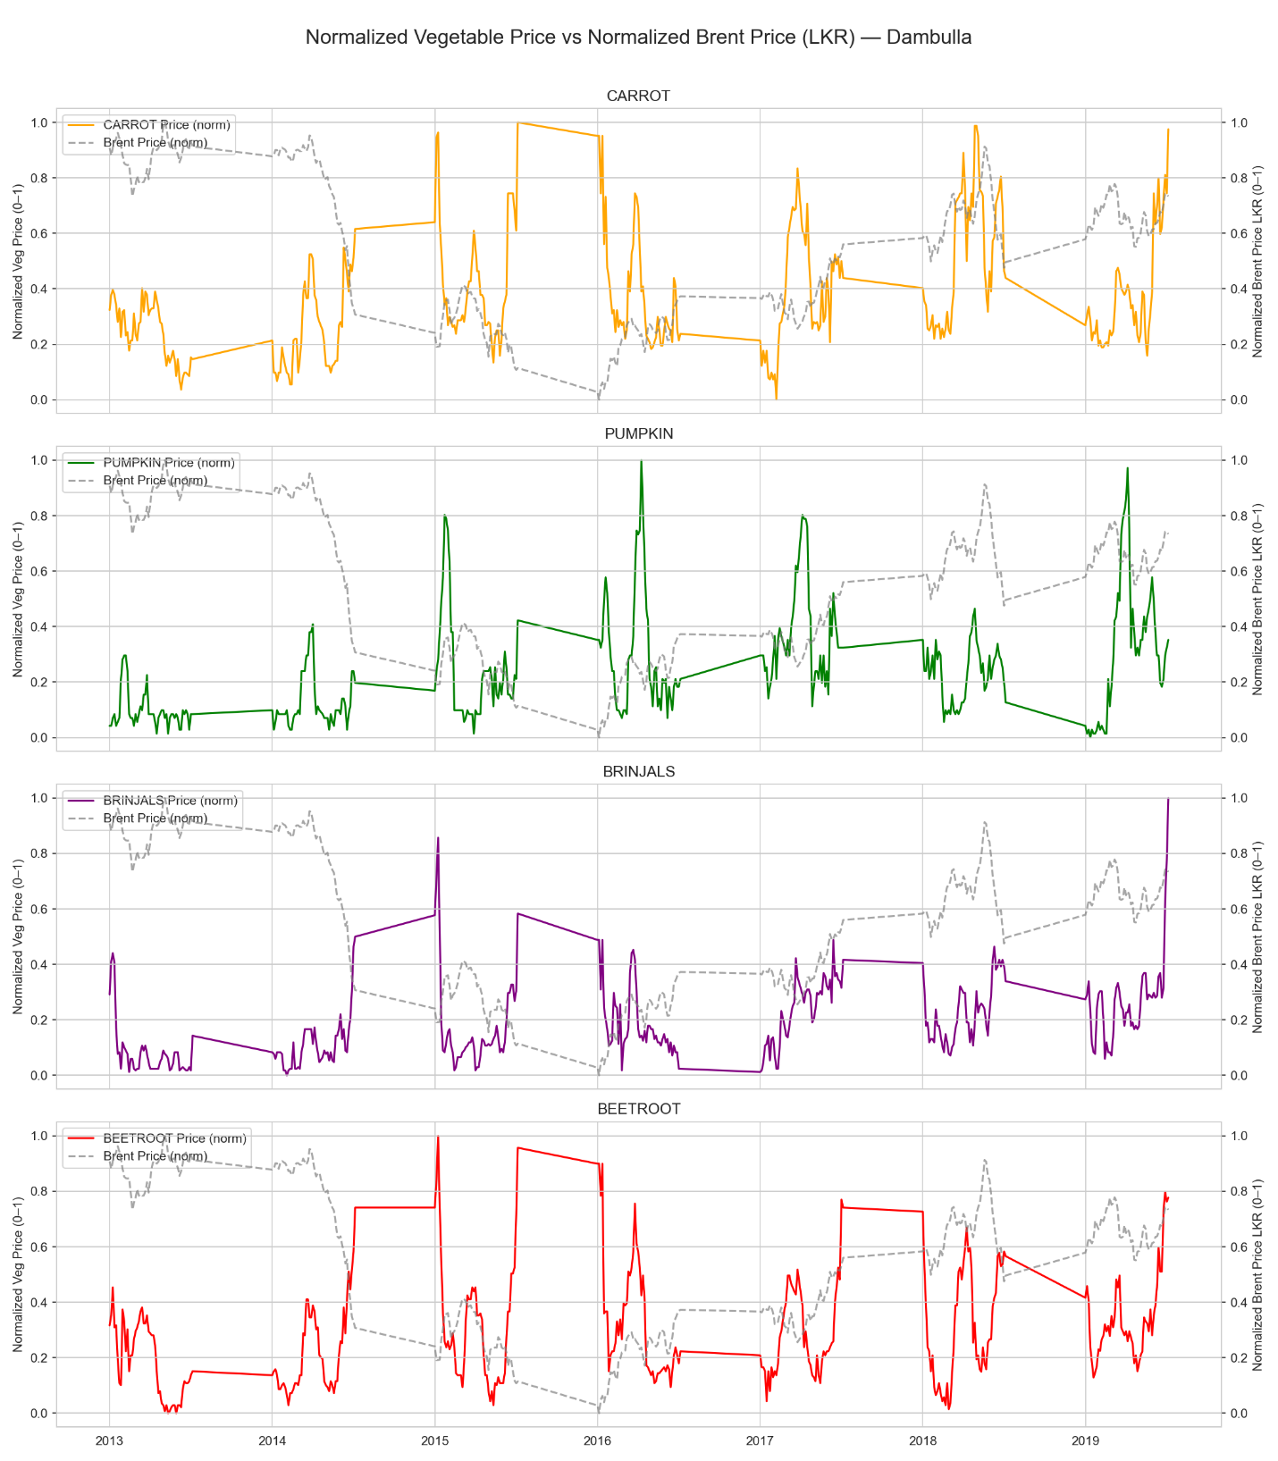

Figure 4. Vegetable prices vs Brent LKR — Colombo, Kandy, and Dambulla, 2013–2019.

4.2 Scatter Plot and Correlation
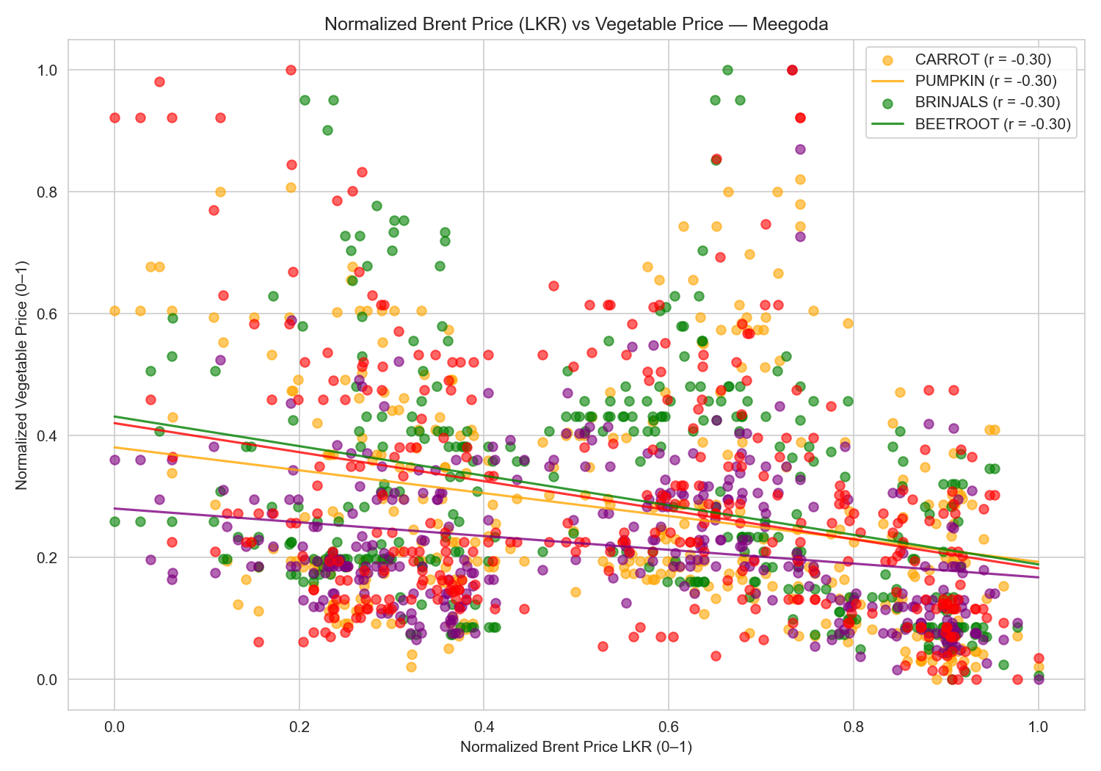
Figure 5. Scatter plot of Brent LKR vs vegetable prices at Meegoda — all years.
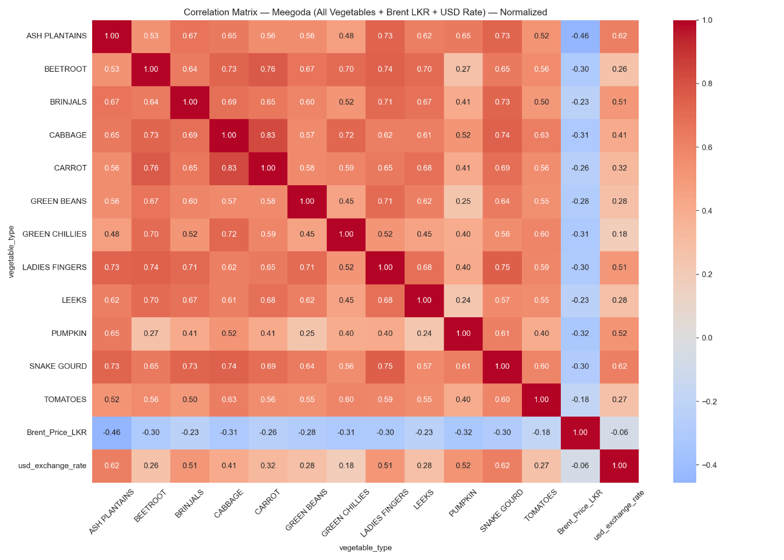
Figure 6. Full correlation matrix at Meegoda — Brent LKR and USD exchange rate included.

5. Diesel Price vs Vegetable Prices — Full Period (2013–2019)
When the full 2013–2019 period is examined, the diesel price shows a negative linear correlation with vegetable prices (-0.16 to -0.54 across vegetables at Meegoda). This is the opposite of the expected cost-push direction and is entirely a product of the step-change regime structure.
From 2013 to 2014, diesel was held at a high administered price (around LKR 117/litre) while vegetable prices were relatively moderate. In early 2015, diesel was cut sharply to around LKR 95/litre as global oil collapsed. Vegetable prices subsequently rose — but due to monsoon-driven supply shocks, not fuel costs. This inversion produces a spurious negative correlation over the full period.
This is precisely why simple correlation analysis would lead a researcher to wrongly exclude diesel as an unimportant feature. Tree-based models avoid this trap because they identify regime boundaries (diesel level thresholds) and apply different conditional relationships within each regime.

5.1 Time Series Comparison (Full Period)
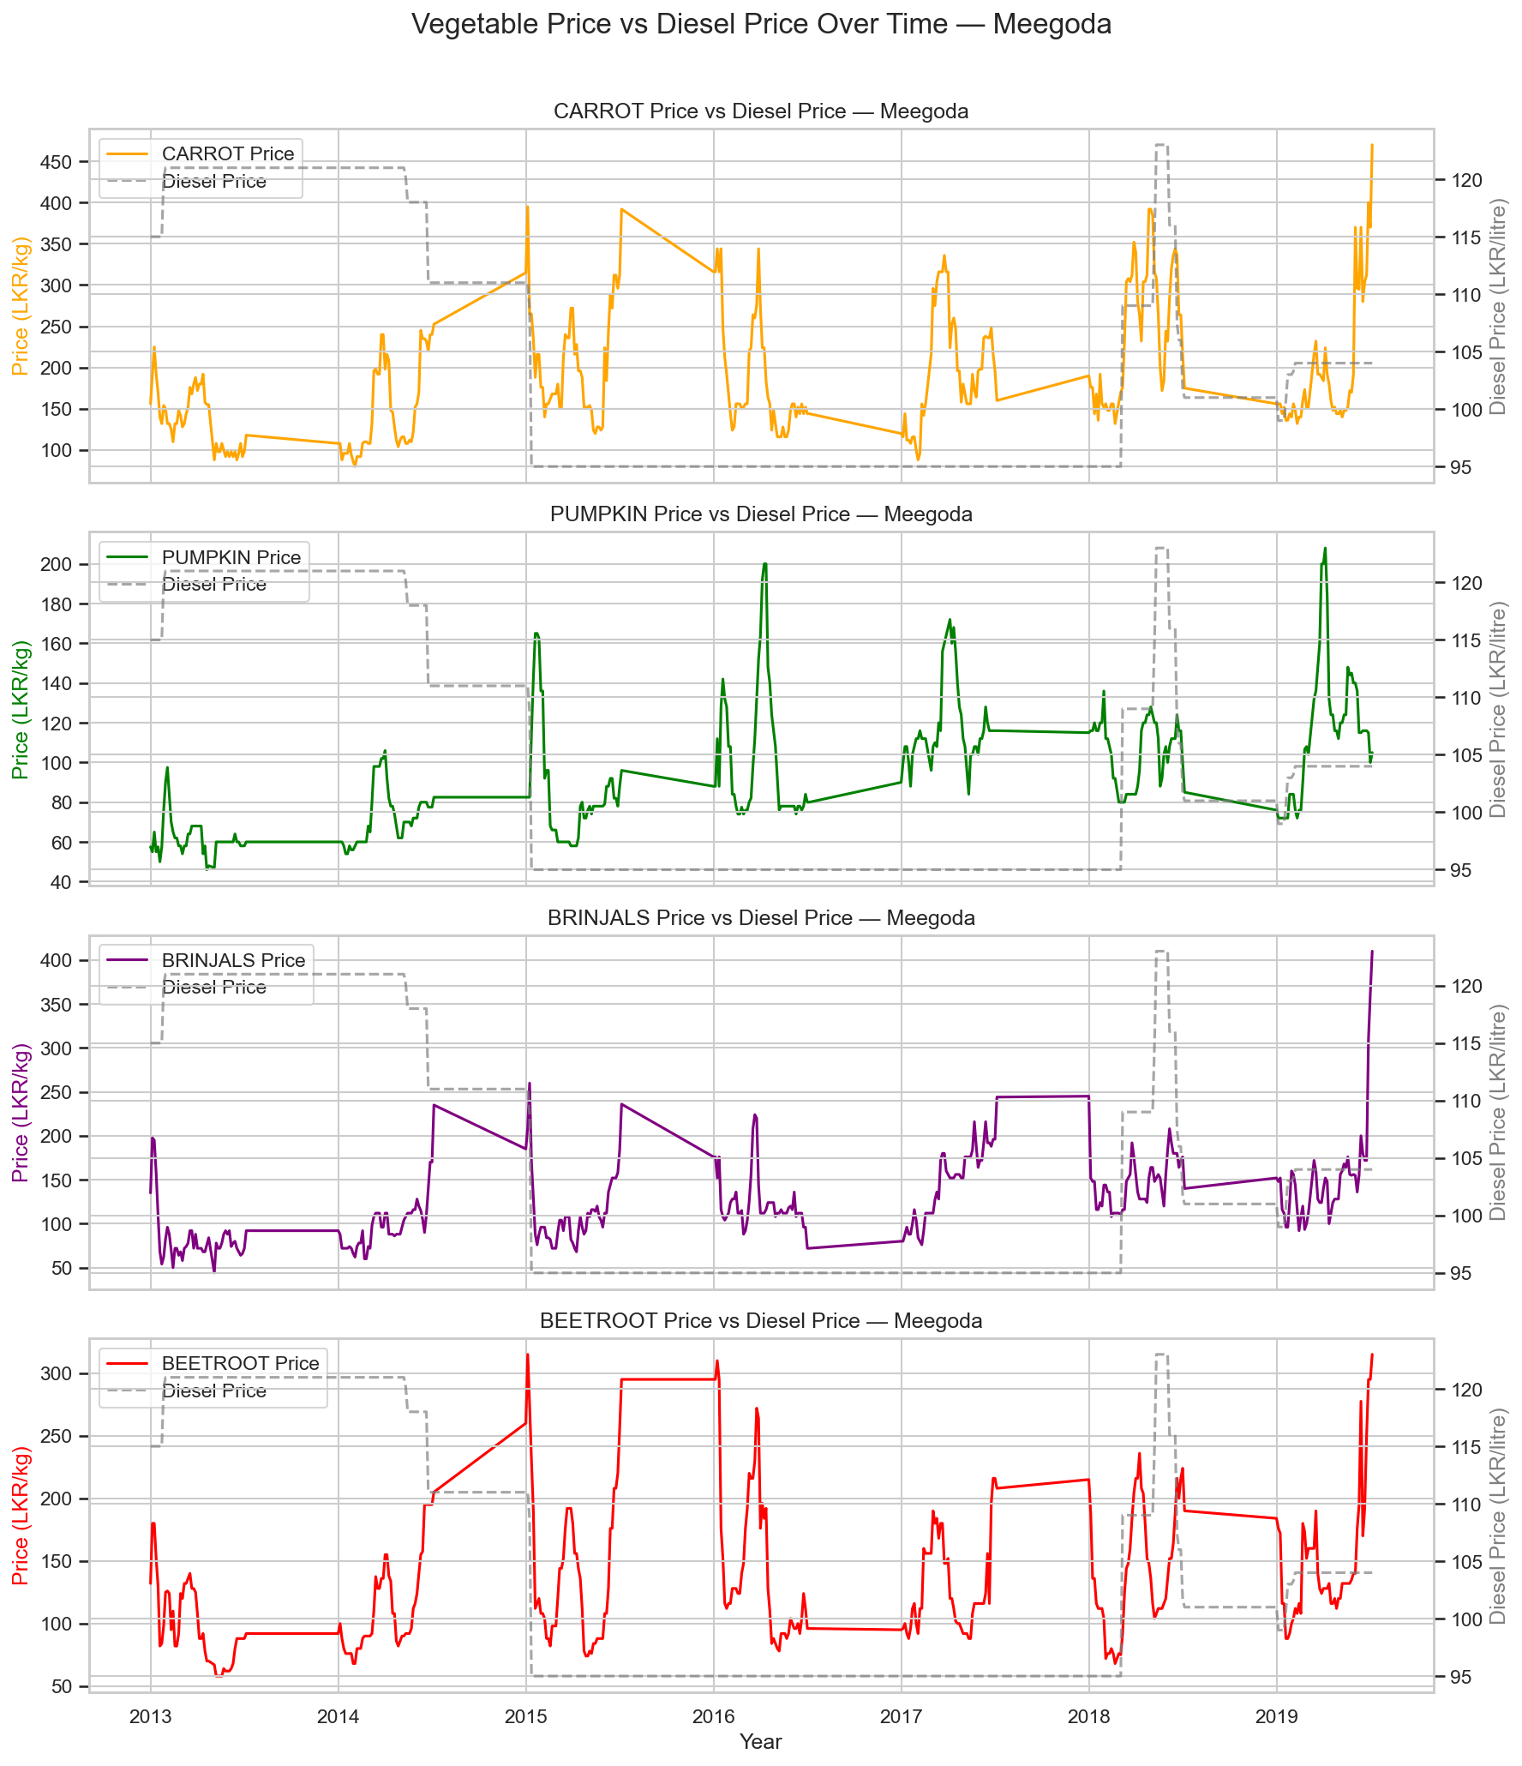
Figure 7. Vegetable prices vs diesel price — Meegoda, full period 2013–2019.
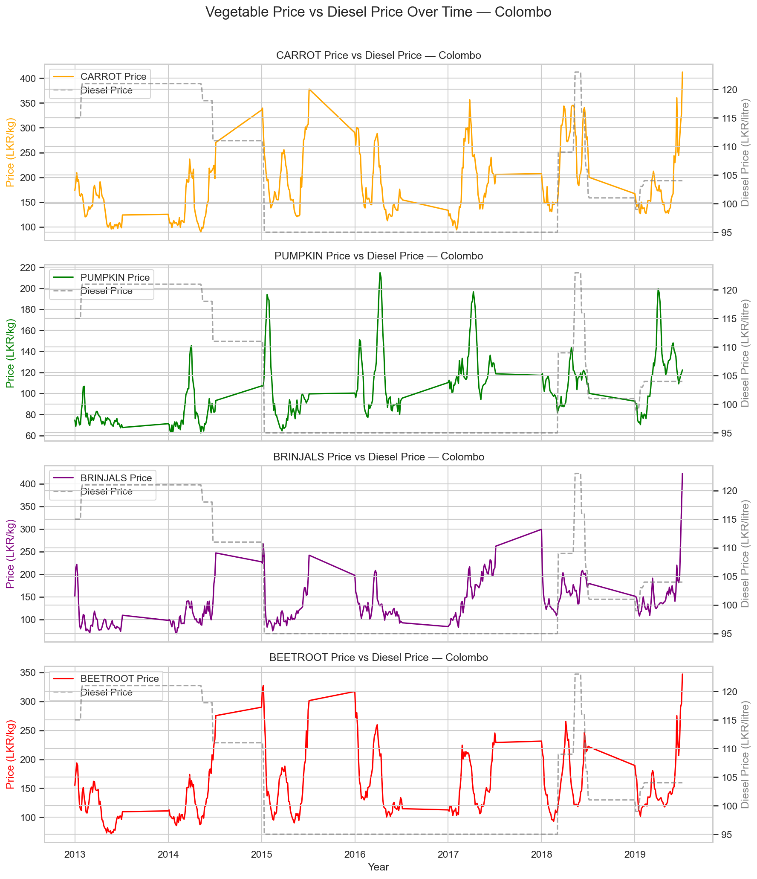
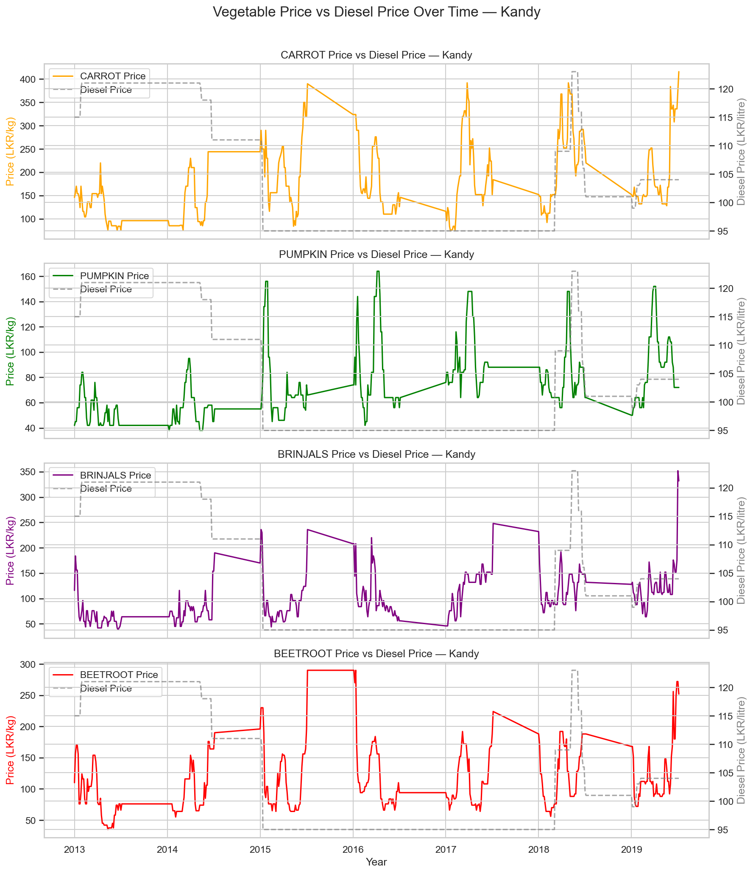

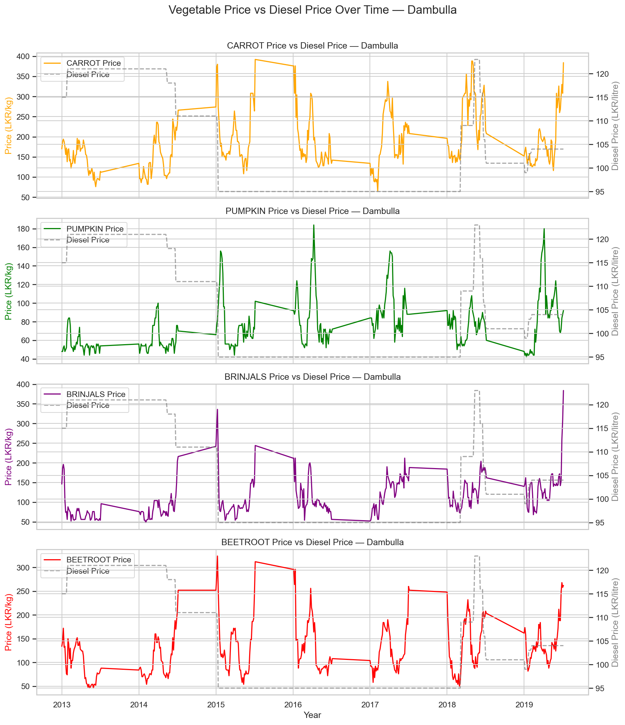
Figure 8. Vegetable prices vs diesel price — Colombo, Kandy, and Dambulla, full period.

5.2 Scatter Plot and Correlation (Full Period)
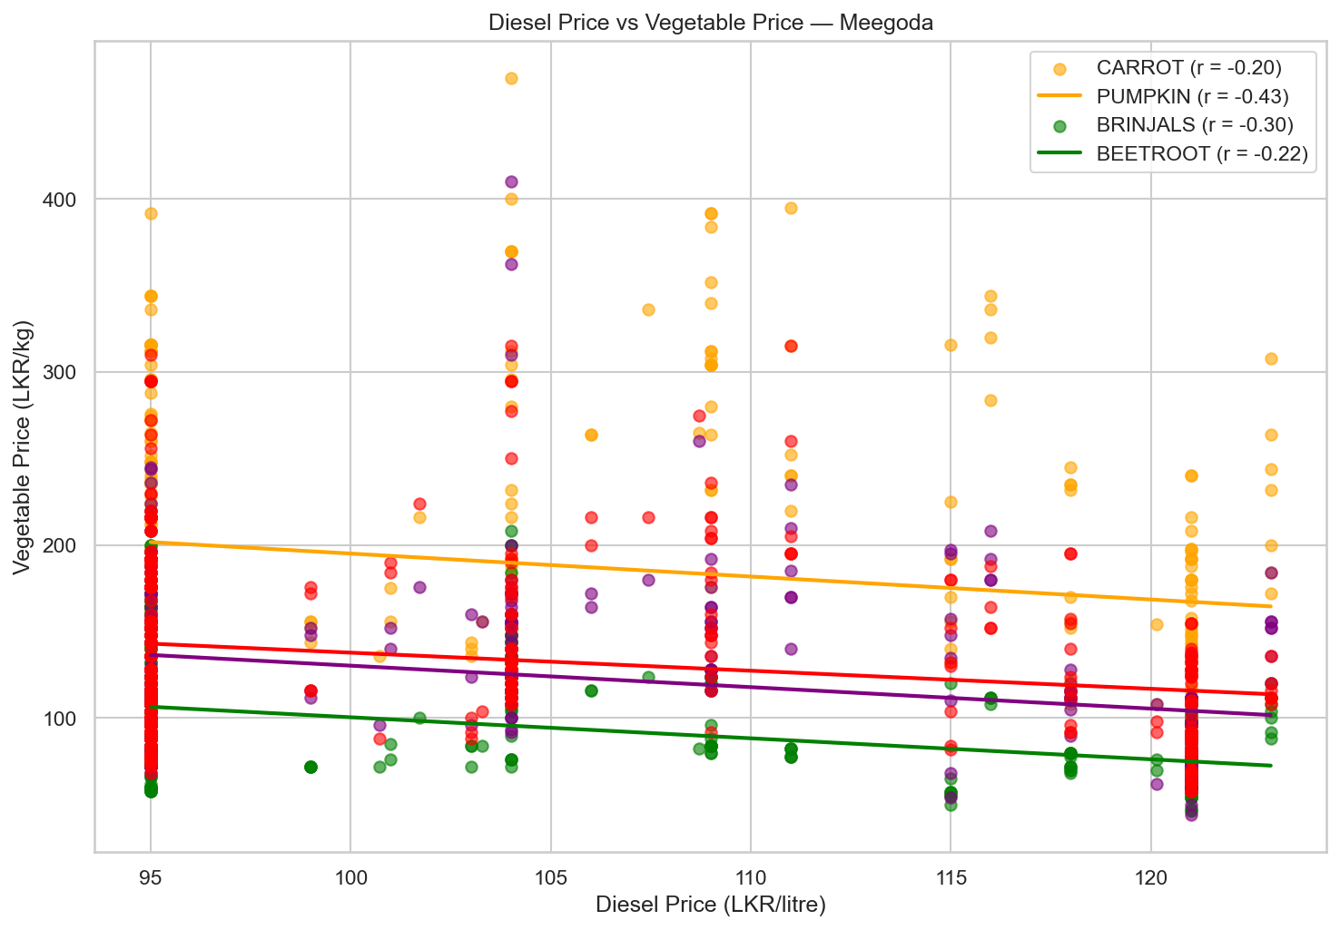
Figure 9. Scatter plot of diesel price vs vegetable prices at Meegoda — full period.
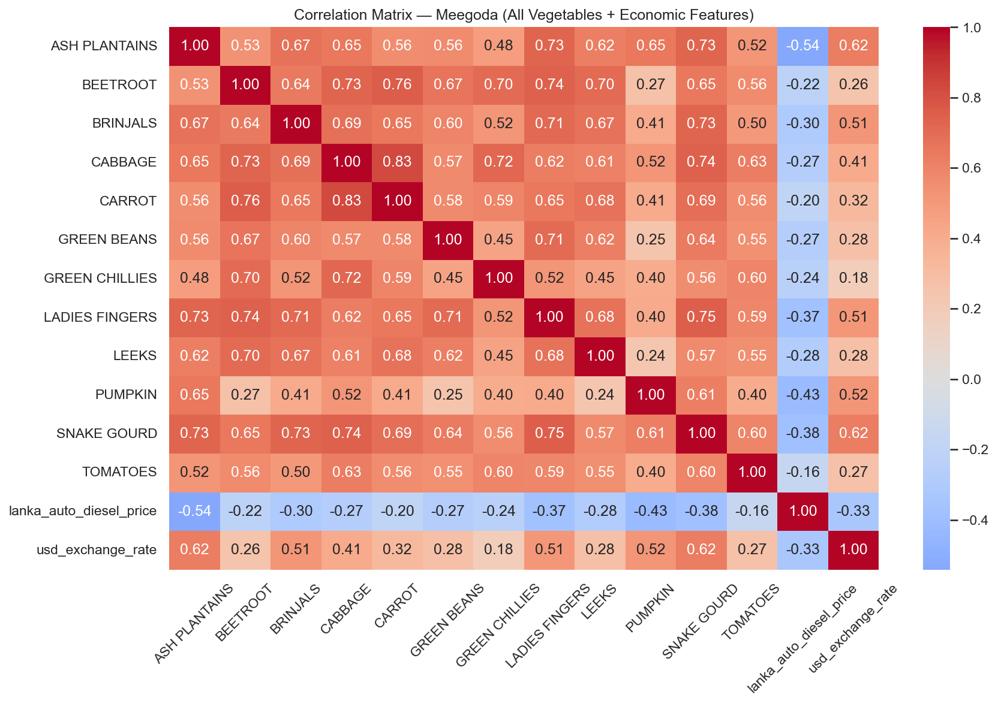
Figure 10. Full correlation matrix at Meegoda — diesel and USD exchange rate, 2013–2019.

6. Diesel Price vs Vegetable Prices — Post-Formula Period (2018–2019)
Subsetting the data to 2018–2019 — the period following the introduction of the monthly fuel pricing formula in May 2018 — reveals a qualitatively different relationship. With diesel now moving more responsively to market forces (though still in steps), the correlation with vegetable prices turns positive and increases substantially for some commodities.
Carrot shows the strongest positive correlation (r = 0.45 at Meegoda), reflecting the high transport intensity of carrot supply chains from the Nuwara Eliya highlands. Pumpkin, Brinjals, and Beetroot show weaker or near-zero correlations in this sub-period, consistent with their being sourced from varied low-elevation origins with less diesel-sensitive logistics.
Mutual information scores confirm a non-linear dependency between diesel price and vegetable prices even where Pearson r is weak, supporting the use of tree-based models that can capture threshold and interaction effects.

6.1 Time Series Comparison (2018–2019)
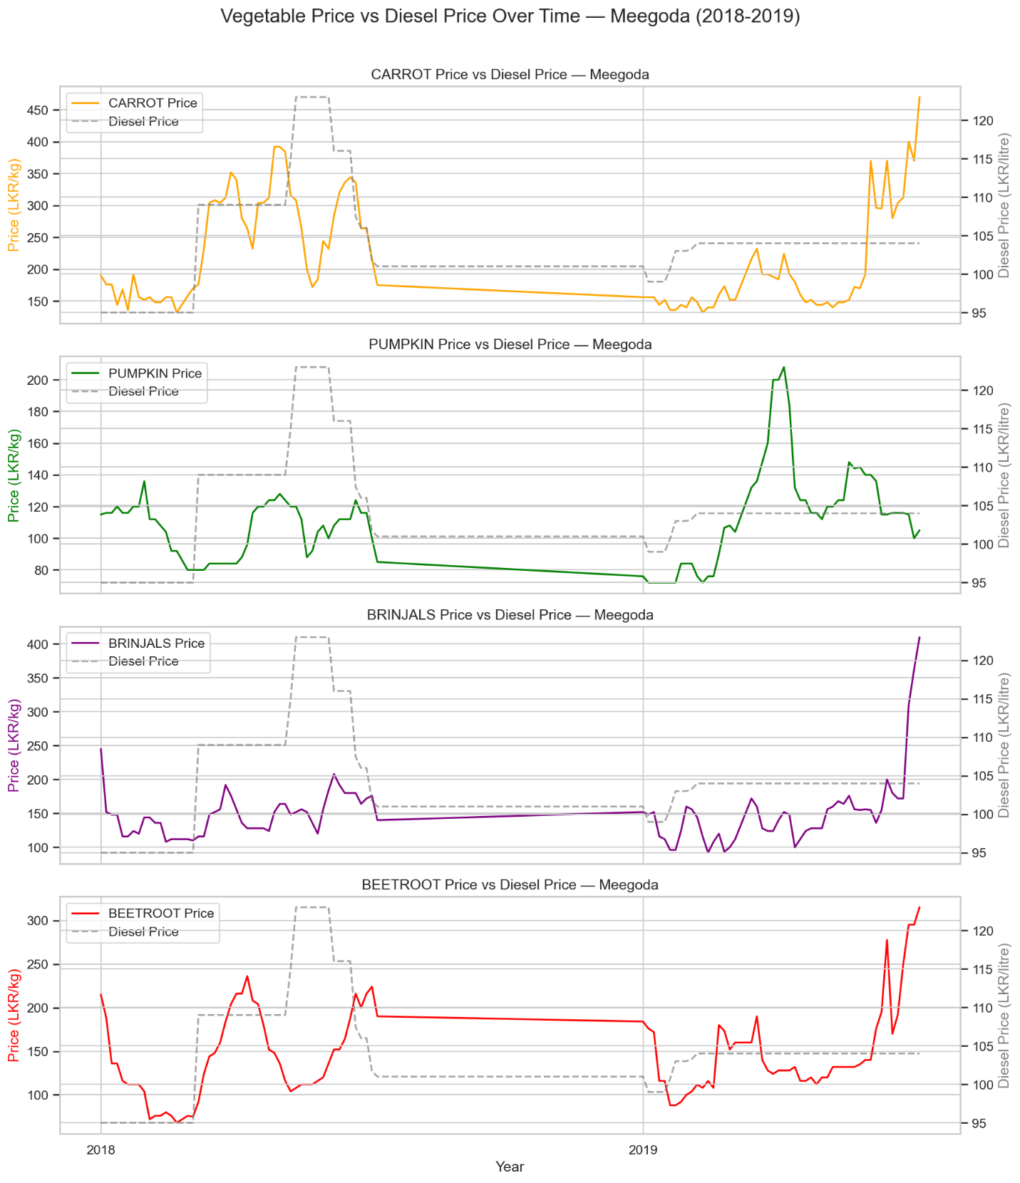
Figure 11. Vegetable prices vs diesel price — Meegoda, 2018–2019.

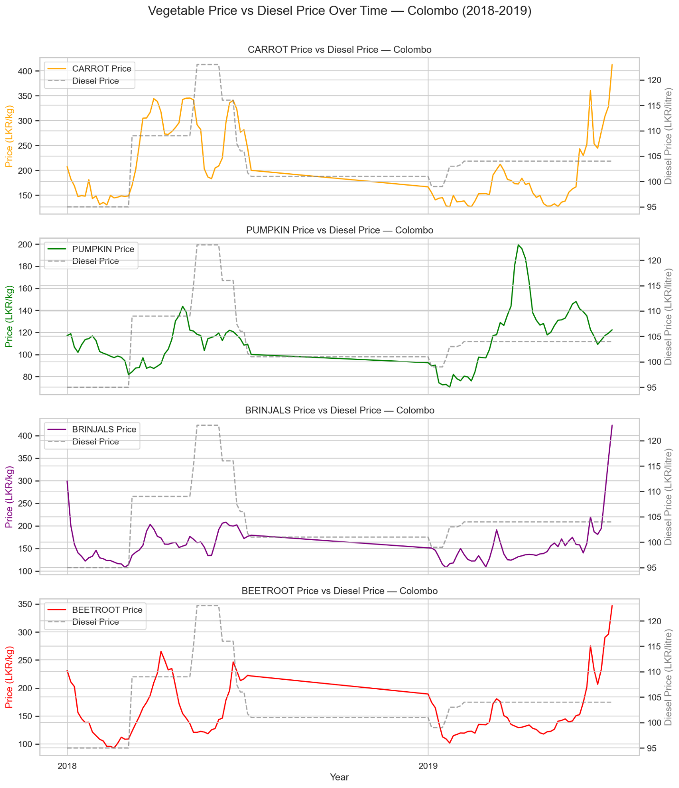

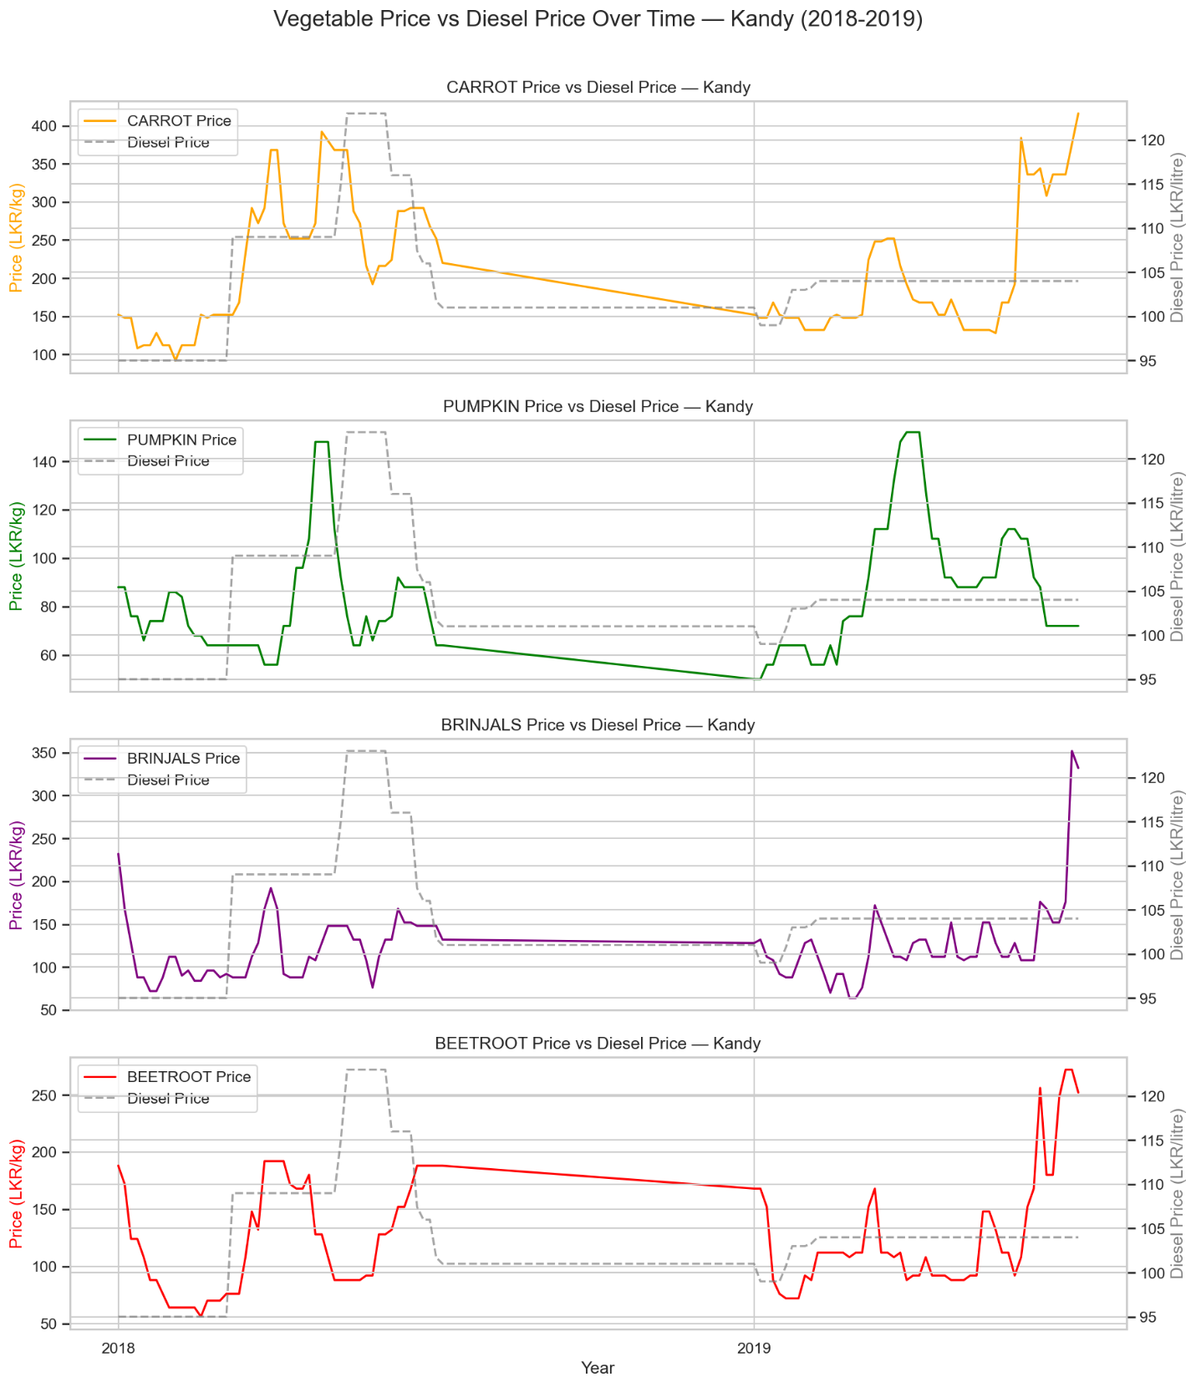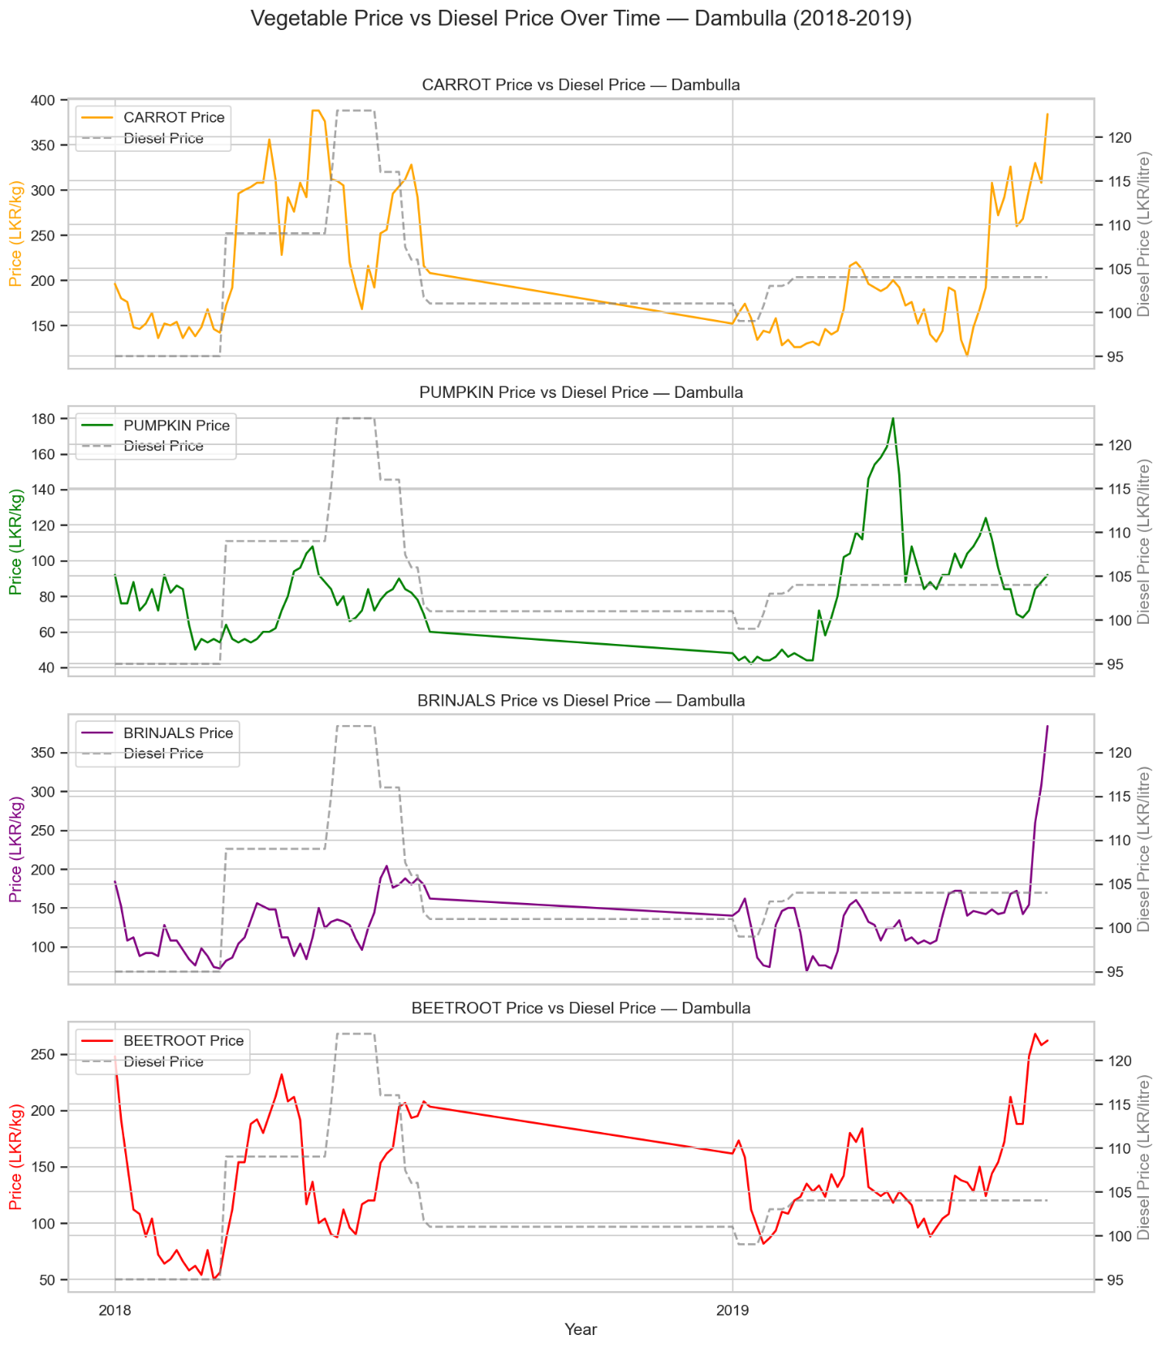
Figure 12. Vegetable prices vs diesel price — Colombo, Kandy, and Dambulla, 2018–2019.

6.2 Scatter, Correlation, and Mutual Information (2018–2019)
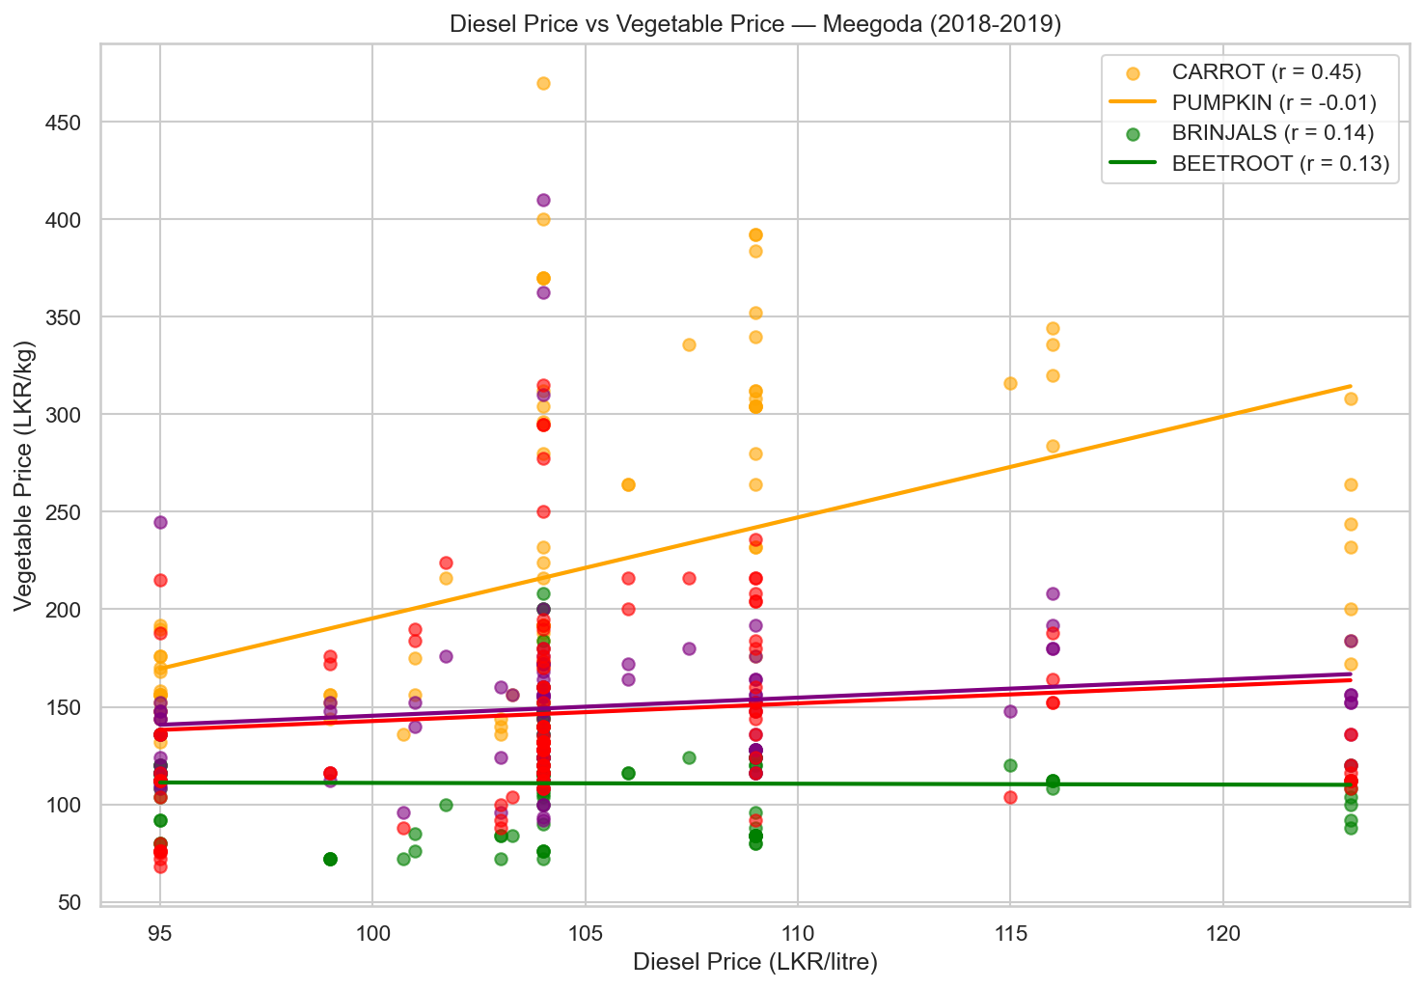
Figure 13. Scatter plot of diesel price vs vegetable prices at Meegoda — 2018–2019.
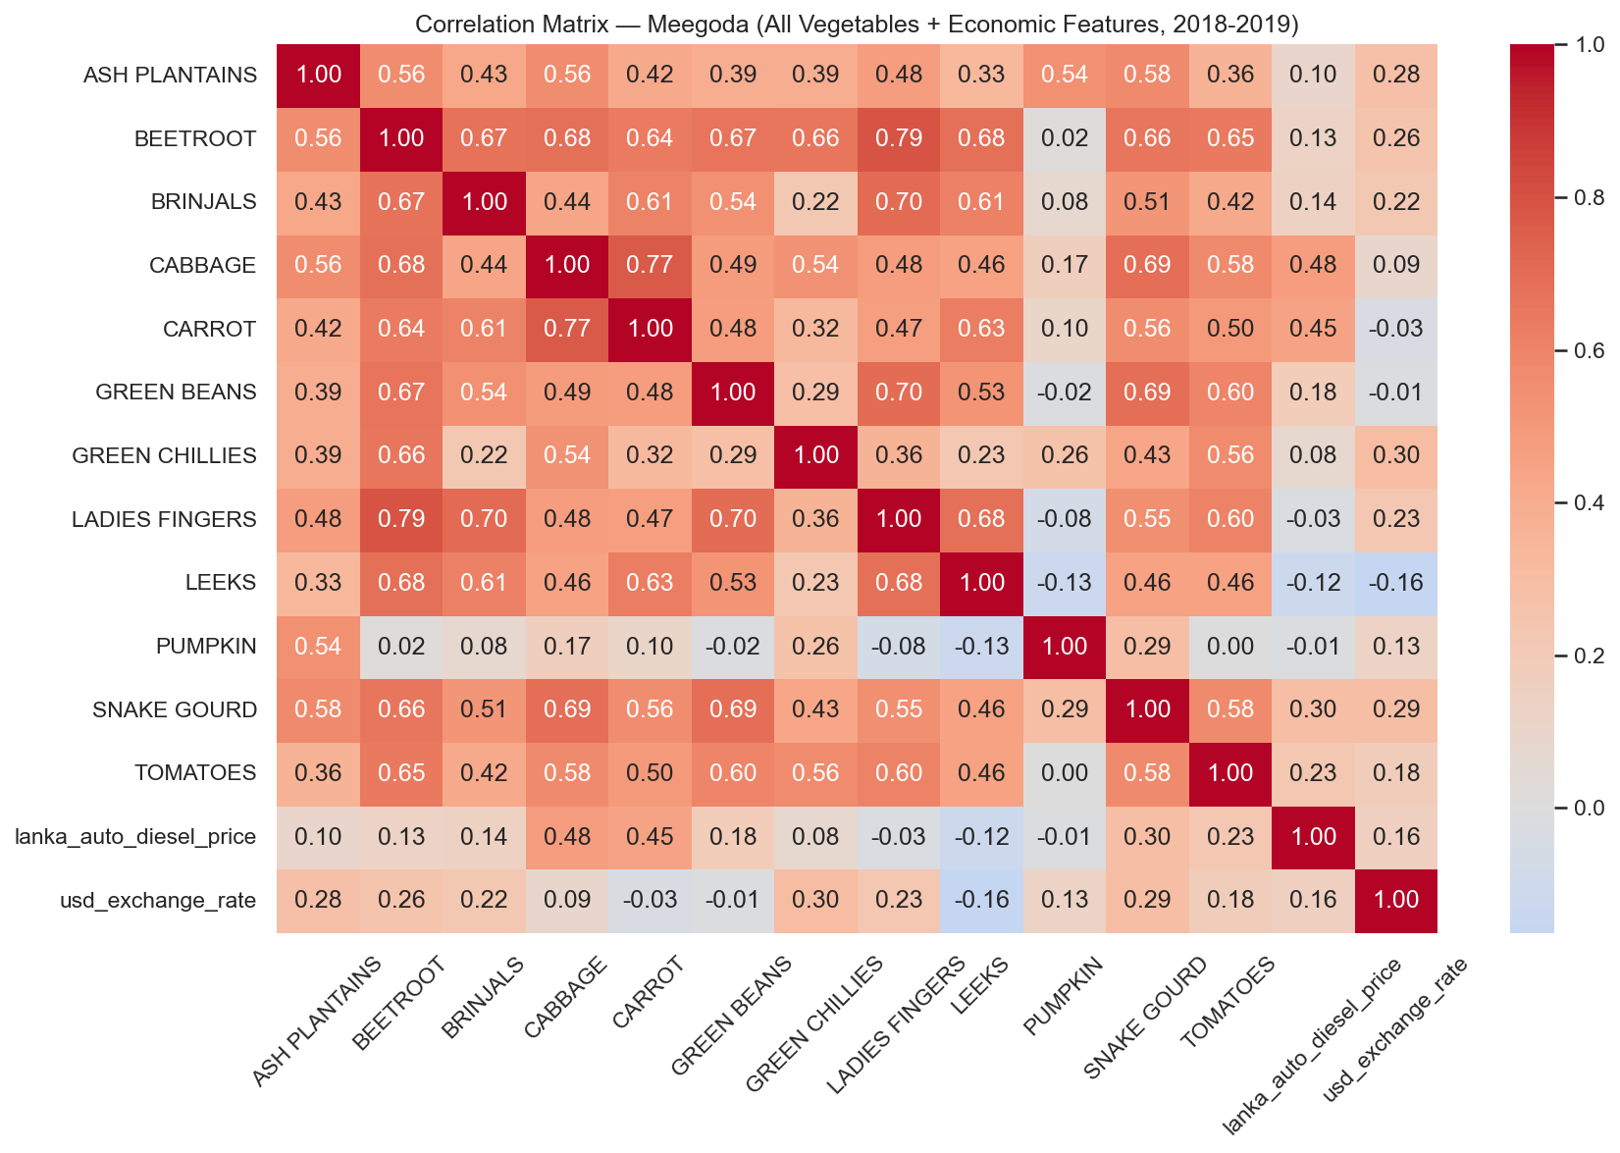
Figure 14. Correlation matrix at Meegoda — 2018–2019 sub-period.
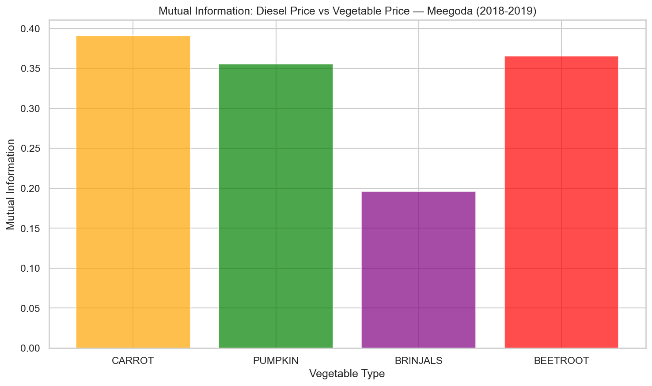
Figure 15. Mutual information between diesel price and vegetable prices at Meegoda — 2018–2019.

7. Key Findings and Implications for Modelling

7.1 Diesel is a Regime Variable, Not a Linear Predictor
The diesel price series cannot be treated as a continuous, linearly-acting feature. Its step-change character means it delineates distinct macro-economic cost eras. Within each era, vegetable prices are governed primarily by weather and seasonal supply cycles. Across eras, the structural cost base for transport shifts, raising or lowering the floor of vegetable prices.

7.2 The Full-Period Negative Correlation is a Statistical Artefact
The negative Pearson correlation between diesel and vegetable prices over 2013–2019 is caused by a confounding period structure: the high-diesel era (2013–2014) coincided with relatively stable vegetable prices, while the post-2015 low-diesel era saw supply-shock-driven price spikes. This artefact would cause a linear model to wrongly conclude that lower diesel prices raise vegetable prices.

7.3 The Formula Period (2018–2019) Reveals the True Direction
When diesel began moving more responsively after the 2018 pricing formula, the cost-push mechanism became visible in the data. Positive correlations and elevated mutual information scores in this sub-period confirm that diesel price increases do eventually translate to higher vegetable prices through increased transport hire rates.

7.4 USD Exchange Rate is a Stronger Linear Predictor
The USD/LKR rate shows consistently positive correlations with vegetable prices across the full period (0.18–0.62). Because it moves continuously and its effect on landed fuel cost is more direct, it serves as a better linear proxy for the macro-economic cost environment. In combination, diesel (regime splitting) and USD rate (continuous drift signal) provide complementary information to tree-based models.

7.5 Inter-Vegetable Correlations are High
Most vegetable pairs show Pearson correlations of 0.4–0.8, reflecting shared seasonal and monsoon-driven supply cycles. Pumpkin is a partial exception, showing lower correlations with several other vegetables, likely due to its different growing calendar and multiple harvest seasons. This inter-correlation structure supports a multi-output or market-wide modelling approach.

8. Conclusion
The EDA confirms that the relationship between fuel costs and vegetable wholesale prices in Sri Lanka is structurally non-linear and regime-dependent. Simple correlation analysis underestimates the importance of diesel price as a feature. Tree-based machine learning models are well suited to this structure because they can identify diesel price thresholds as regime boundaries and model conditional relationships within each regime.
The findings support the inclusion of both lanka_auto_diesel_price and usd_exchange_rate as features in the predictive model, alongside weather and seasonal signals. Neither economic nor weather features alone are sufficient; their interaction explains the full variance structure of weekly vegetable prices.

